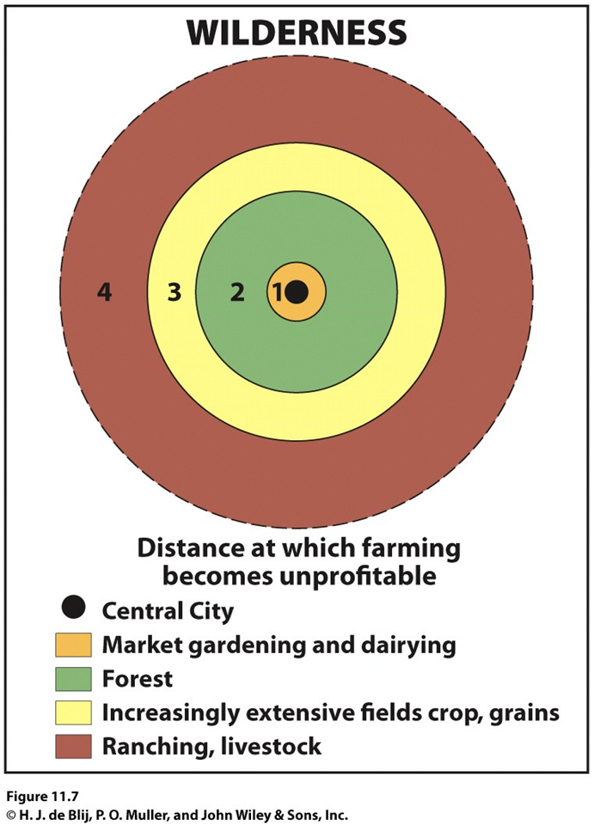
Von Thunen Model

Basis:

Below, list any information you think is important.

- Village / Central City

2. Labor-Intensive (veg, dairy)

3. Managed Forest

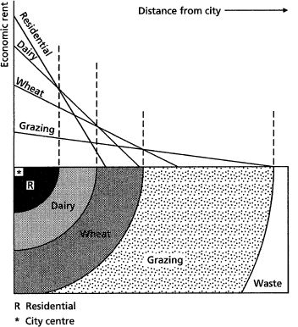

4. Extensive crops (grains)

- Grazing

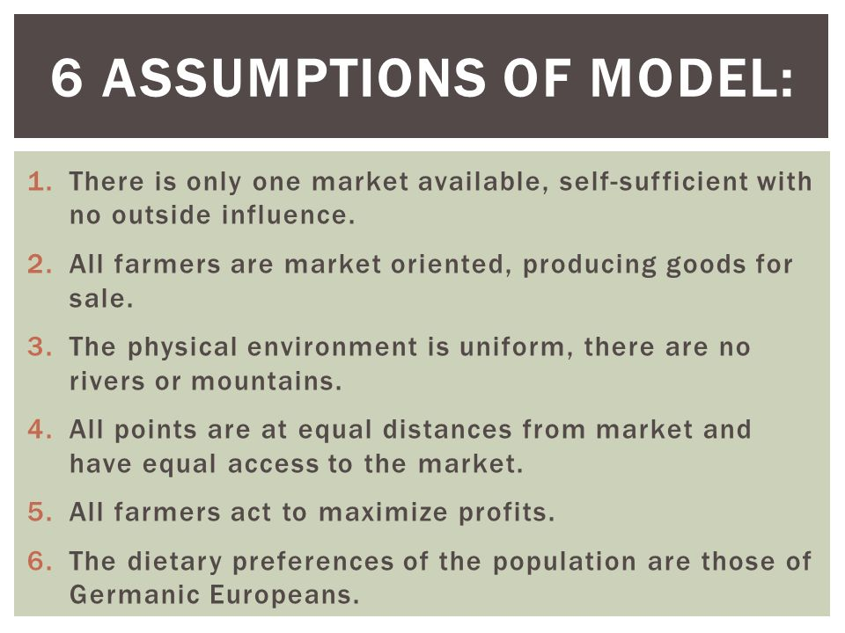

Map A shows Von Thunen applied if NYC was the only market; Map B changes the model based on climate and what grows well in different climates…looks pretty accurate huh? Why do Southern California and Florida not fit the model?


