VEGETATIVE PLANTING HEARTHS & DIFFUSION
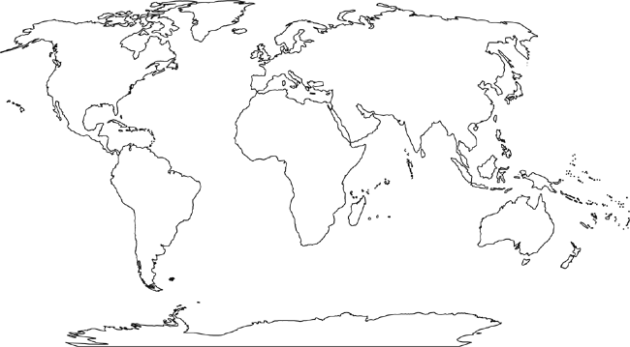

SEED AGRICULTURE HEARTHS AND DIFFUSION
HEARTHS OF ANIMAL DOMESTICATION

