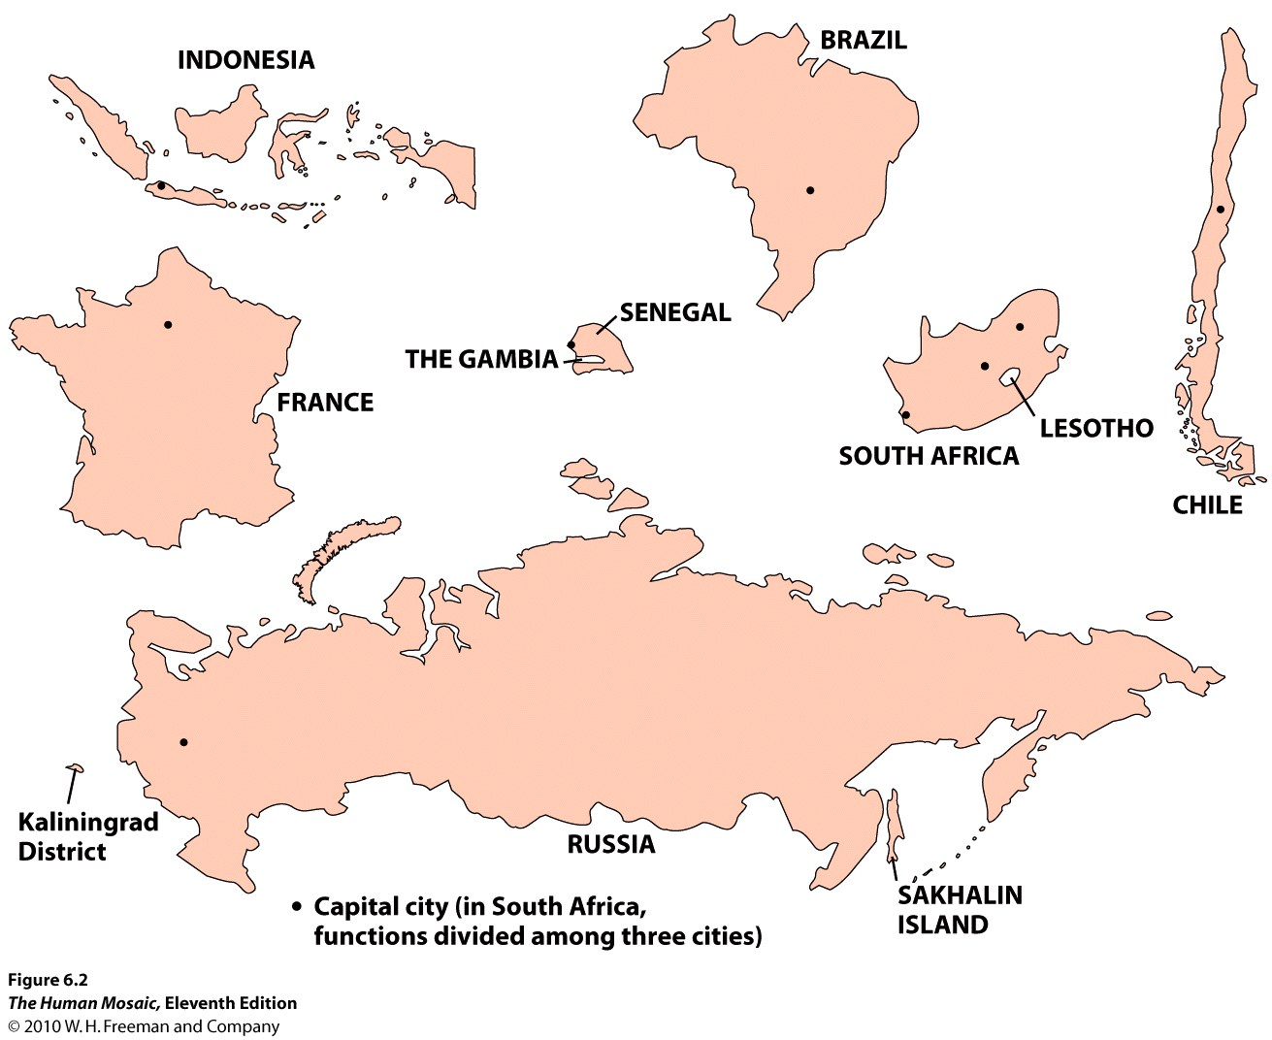
THE SHAPES OF STATES Name: ___________________________________________ Class: _____
- What was the purpose of the Berlin Conference? How did it impact the boundaries of Africa?

- Give at least TWO modern (last fifty years) examples of fortified boundaries and briefly discuss why these “walls” were built.

- What was the Balfour Declaration of 1917? What were the consequences of this declaration?

THE SHAPES OF STATES

1. Label examples of state shapes that you see on the map on the back - use list of terms that may apply below.
2. Fill out the chart on state shapes
3. Answer the questions next to the state shapes on the back

State Shape | Advantage | Disadvantage | Examples (At least 3)
Compact state
Prorupted state
Elongated state
Fragmented state
Perforated state
Enclave
Exclave
Island
Landlocked

