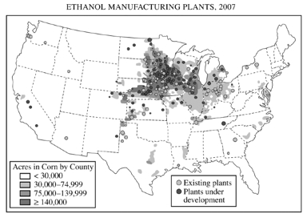
UNIT 6 FRQs: Industrialization and Development
1. WEBER: According to Alfred Weber’s theory of industrial location, three factors determine the location of a manufacturing plant: the location of raw materials, the location of the market, and transportation costs.
A. Using an example of a specific industry other than the one portrayed on the map above, explain under what conditions an industry would locate near the market.
B. Using an example of a specific industry other than the one portrayed on the map above, explain under what conditions an industry would locate near raw materials.
C. Using the map above and Weberian theory, explain the geography of ethanol plants in the United States.
2. ECONOMIC & SOCIAL CHANGE: Development results in a number of economic and social changes within a country.
- Define primary, secondary, and tertiary economic activities.
- Explain TWO different reasons for each of the following changes that typically occur as a country develops over time.
- Declines in primary sector employment
- Decreases in infant mortality rate
- Improvements in women’s social status
3. ROSTOW & WALLERSTEIN: Rostow’s five-stage model of economic growth and the core-periphery concept of Wallerstein’s three-part world system theory are two of the more common economic development models.
A. Identify and compare three differences between the stages of economic growth and the core-periphery model.
B. Use one of the two models to explain the level of economic development in either Mexico or Brazil.
C. Give two examples of how the core-periphery concept can be applied below the national scale.

