ESPeN

Economic  - Money  - Rich/Poor  - Developed/Undeveloped  - Capital  - Trade  - Tourism  - Business  - Industry  - Economic sectors  - Capitalism  - Labor movements/organizations  - Market and Command Economies  - Business Organizations  - Education | Social  - Social /Economic classes  - Gender  - Age Grading  - Race, Ethnicity, Sexuality  - Culture  - Religion / Belief Systems  - Philosophy  - Art, Music, Literature  - Leisure  - Elites/ Inequalities  - Innovations  - Language  - Social Norms
Political  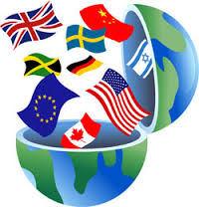  - Nations/ Nationalism  - Flag  - Public Land  - Laws  - Permits  - Empires/ Rulers  - Forms of Government  - Boundaries  - States  - Conflicts/Revolts/Revolution  - Geopolitics  - Government Policies / Laws | eNvironmental  - Location  - Regions  - Physical geography  - Aesthetics  - Pollution  - Human Interaction with Earth  - Desertification / Erosion  - Greenhouse Effect  - Urbanization / Cities  - Environment / Land Management  - Settlement and Migration Patterns

