Diffusion of Industrialization
Trace the spread of industrialization in Europe, labeling the major areas: UK, Ruhr Valley & Saxony (Germany), Silesia (Poland), and the Donbas (Ukraine/Russia) + Moscow & St. Petersburg (Russia)…include the dates.
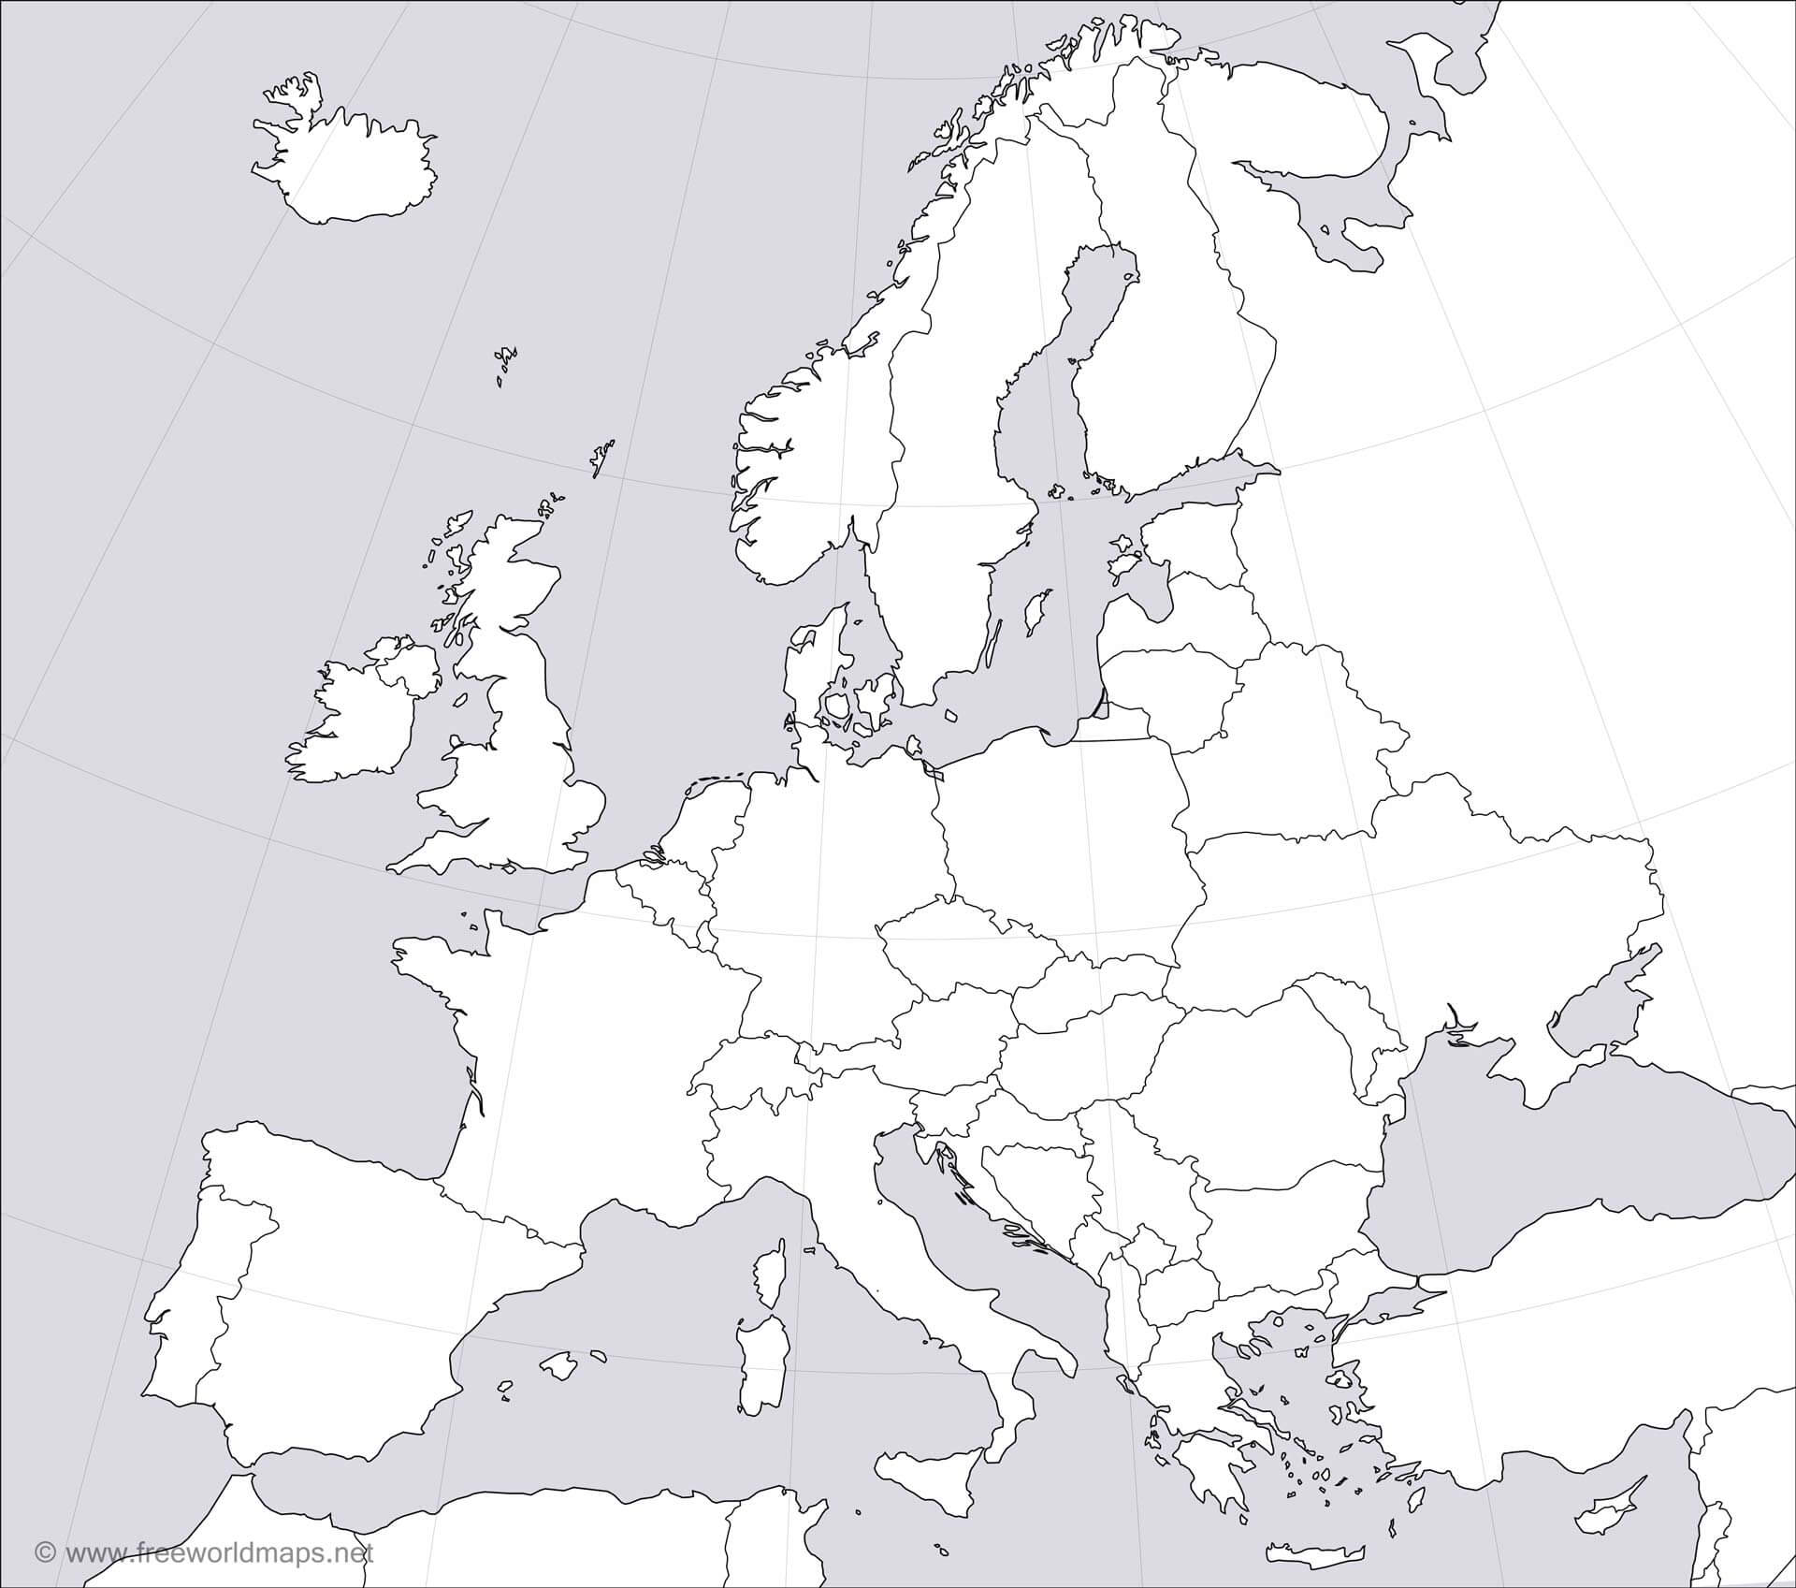

Label/shade primary industrial regions in early industrialization: western Europe, eastern North America, western Russia and Ukraine, and Japan (Kanto Plain)
North America: Manufacturing began in colonial New England

