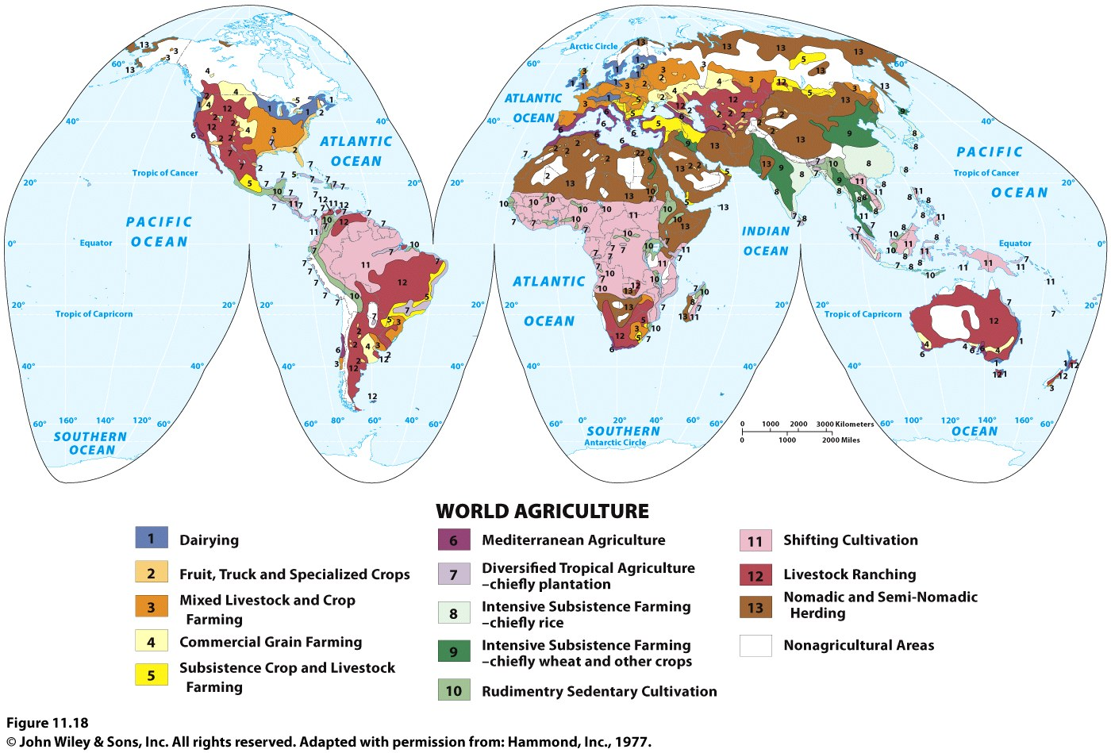
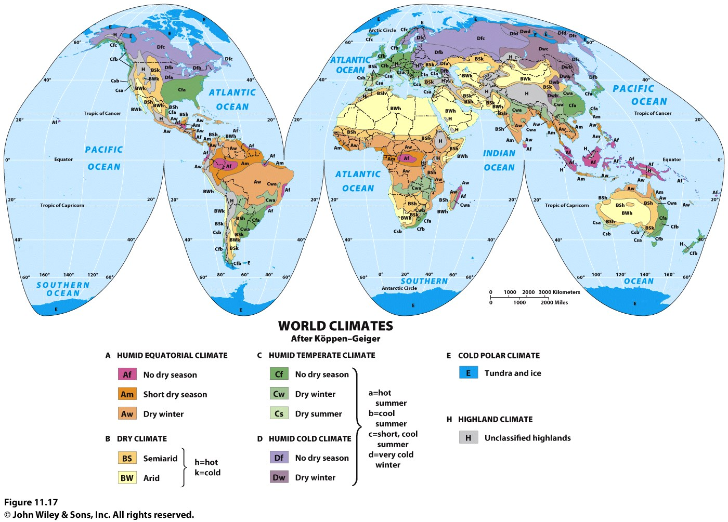
- The “no dry season” (Af) regions are equatorial rainforest climate.

- The “short dry season” (Am) climate is known as the monsoon climate.

- BW is desert and BS is steppe.

- “Dry summer” (C) climates are known as Mediterranean climates.

- Polar climates (E), where tundra and ice prevail, are found poleward of (D) climates.

